Chapter 4, Problem 5.

For the circuit in Fig. 4.73, assume v_{o} = 1 V, and use linearity to find the actual value of v_{o}.

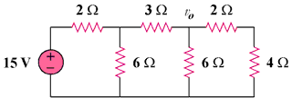

Figure 4.73
For Prob. 4.5.

